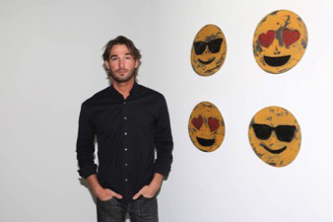

Nick Moss
Substitute For Words
February 13- April 15, 2019

For the winter season, the Casterline|Goodman Gallery will feature artist Nick Moss with his show: Substitute For Words from February 13, 2019 to April 15, 2019.

Nick Moss was born in 1985 in Metamora, Michigan. Moss worked on an intensive crop farm and with an industrial contracting company, he then studied welding and metal fabrication before relocating to New York City in 2007. In 2008, Moss joined Traeger Wood Pellet Grills and was given full control of creation, concept, and industrial design including re-engineering, where the product was made primarily of steel. By 2014, Moss moved towards pursuing his artistic practice, continuing to experiment with welding and steel which later developed into his unique process of art fabrication today. Moss makes all his work entirely by hand without studio assistance, through a process that’s highly dangerous and requires dexterity and attention to detail while behind a full face welding helmet.

In his new series, Moss created Emojis that represent “the deterioration of language”. Taking these images that express laughter, anger, happiness and sadness, he exploits the physical properties of the steel to create a patina that individualizes each emoji. His format is typically 12, 36 or 46 inches in diameter, many times larger than we see it on our screens. Moss reminds us that while emojis clarify a tone of voice in the overly technological world, they are no substitute for our own words.

